# Carly Heibel and Michael Royappa

Milestone 1

CSSE477

# POST Request

File Hierarchy before POST:

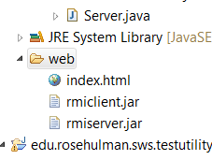

POST Request:

POST /temp.txt HTTP/1.1

content-length: 463

referer: http://localhost:8080/upload.html

accept-language: en-US,en;q=0.8

origin: http://localhost:8080

host: localhost:8080

connection: keep-alive

content-type: multipart/form-data; boundary=----WebKitFormBoundaryEzjCwl5nt4xFk9AS

cache-control: max-age=0

accept-encoding: gzip, deflate

accept: text/html,application/xhtml+xml,application/xml;q=0.9,image/webp,*/*;q=0.8

User-Agent: HttpTestClient/1.0

"This is the content of the temp.txt file."

Output of POST in TestClient:

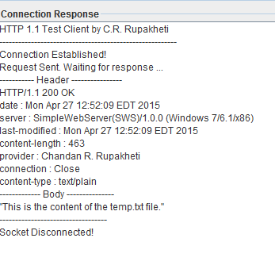

File Hierarchy after running POST Request:

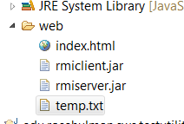

File contents after successful POST:

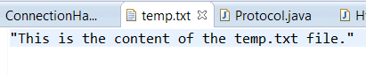

# PUT Request

PUT Request:

PUT /temp.txt HTTP/1.1

content-length: 60

referer: http://localhost:8080/upload.html

accept-language: en-US,en;q=0.8

origin: http://localhost:8080

host: localhost:8080

connection: keep-alive

content-type: multipart/form-data; boundary=----WebKitFormBoundaryEzjCwl5nt4xFk9AS

cache-control: max-age=0

accept-encoding: gzip, deflate

accept: text/html,application/xhtml+xml,application/xml;q=0.9,image/webp,*/*;q=0.8

User-Agent: HttpTestClient/1.0

"PUT REQUEST: This is the content of the temp.txt file."

Output of PUT Request in TestClient (deleted temp.txt, so it should re-create it):

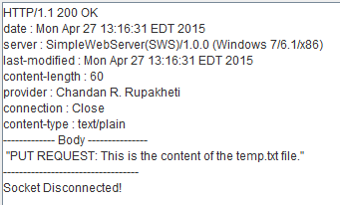

File Hierarchy after running PUT with no existing temp.txt:

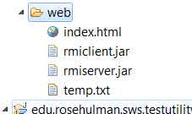

Contents of new temp.txt:

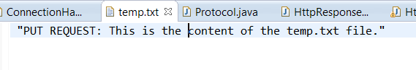

PUT Request after file already exists:

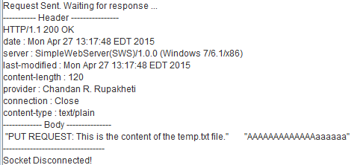



File Structure doesn’t change:

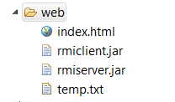

# DELETE Request